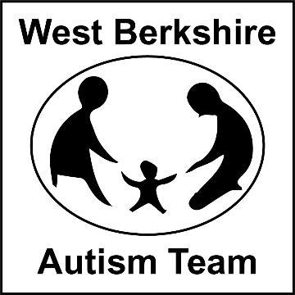**For Families whose child has recently received a diagnosis of autism.**

**Newly Diagnosed Autism Support Group**

You have just recently learnt that your child has been diagnosed with autism. For some parents, the news comes as a shock, while other parents may have been expecting it and it can be a relief to finally have a diagnosis. However, the most important thing to know is that ‘You are not alone’, and we are here to support you and signpost you to other organisations / families in the area that can offer you support.

[](https://www.google.com/url?sa=i&url=https://www.spectrumnews.org/news/autism-diagnosis-explained/&psig=AOvVaw0uBs19GUjTq1bdJFdoxh2R&ust=1609857730843000&source=images&cd=vfe&ved=0CAIQjRxqFwoTCPD9xZrBgu4CFQAAAAAdAAAAABAD)

Come along our 2 part workshops to meet the West Berks Autism Team, learn more about us and top tips to start you on your journey of understanding autism and how best to support your young person (**choose either** the Morning Autism Support Group on 16th and 23rd September) or the dates in January or June.

**Morning**

**Day 1** Date: 16th September 2024 **Day 2** Date: 23rd September 2024

**Time:** 9.45am – 12.00pm

**Venue:** Shaw House, Church Road, Shaw House Newbury, RG14 2DR

**Next Dates:**

**14th January and 21st January 2025**

**11th June and 18th June 2025**

**There will also be time to discuss any questions or concerns you may have.**

**Presenters:**

**Kelly Evans Lesley Botchway Sue Granger Gilly Rogers**

**Please contact Admin to book a place on: 01635 503646 or Email** [**LearningSupportTeam@westberks.gov.uk**](mailto:LearningSupportTeam@westberks.gov.uk)