**COLLEGE OPEN EVENTS FROM SPETEMBER 2025**

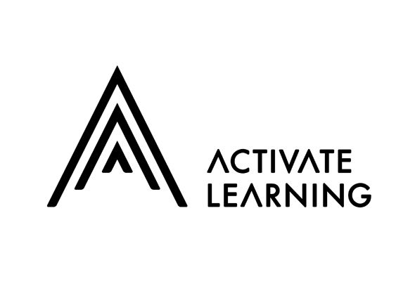

**BRACKNELL AND WOKINGHAM COLLEGE**

**18th October, 9:30am - 12pm** [Bracknell and Wokingham College October Open Event - Bracknell and Wokingham College](https://bracknell.activatelearning.ac.uk/events/detail/bracknell-and-wokingham-college-october-open-event/)

**19th November, 4:30pm - 7pm** [Bracknell and Wokingham College November Open Event - Bracknell and Wokingham College](https://bracknell.activatelearning.ac.uk/events/detail/bracknell-and-wokingham-college-november-open-event/)

**MERRIST WOOD COLLEGE**

**15th October, 4:30pm - 7pm** [Merrist Wood College October Open Event - Merrist Wood College and University Centre](https://merristwood.activatelearning.ac.uk/events/detail/merrist-wood-college-october-open-event/)

**8th November, 9:30am - 12pm** [Merrist Wood November Open Event - Merrist Wood College and University Centre](https://merristwood.activatelearning.ac.uk/events/detail/merrist-wood-november-open-event/)

**READING COLLEGE**

**15th October, 4:30pm - 7pm** [Reading College October Open Event](https://reading.activatelearning.ac.uk/events/detail/reading-college-october-open-event/)

**8th November, 9:30am - 12pm** [Reading College November Open Event - Reading College](https://reading.activatelearning.ac.uk/events/detail/reading-college-november-open-event/)



**BCA COLLEGE**

**4TH October 2025, 15th November 2025, 18th April 2026** [Events Archive - Berkshire College of Agriculture - BCA](https://www.bca.ac.uk/information/open-days-events/)

**SLOUGH & LANGLEY COLLEGE**

**5th November, 16:00 - 18:30 pm** [Slough & Langley College November Open Evening - 5th November 2025 - Windsor Forest College](https://www.windsor-forest.ac.uk/about-us/events-and-open-days/slough-langley-college-november-open-evening-5th-november-2025/)

**25th March 2026, 16:00 - 18:30 pm** [Slough & Langley College March Open Evening - 25th March 2026 - Windsor Forest College](https://www.windsor-forest.ac.uk/about-us/events-and-open-days/slough-langley-college-november-open-evening-5th-november-2025-2/)

**24th June 2026, 16:00 - 18:30 pm** [Slough & Langley College June Open Evening - 24th June 2026 - Windsor Forest College](https://www.windsor-forest.ac.uk/about-us/events-and-open-days/slough-langley-college-march-open-evening-25th-march-2026/)



**STRODE’S COLLEGE**

**23rd October, 16:30 - 19:00 pm** [Strode's College October Open Evening - 23rd October 2025 - Strode's College](https://www.strodes.ac.uk/information/open-days-events/detail/strodes-college-october-open-evening-23rd-october-2025/)

**12th February 2026, 16:30 - 19:00 pm** [Strode's College February Open Evening - 12th February 2026 - Strode's College](https://www.strodes.ac.uk/information/open-days-events/detail/strodes-college-february-open-evening-12th-february-2026/)

**2nd July 2026, 16:30 - 19:00 pm** [Strode's College February Open Evening - 2nd July 2026 - Strode's College](https://www.strodes.ac.uk/information/open-days-events/detail/strodes-college-february-open-evening-2nd-july-2026/)



**WINDSOR COLLEGE**

**14th October 2025, 16:30 - 19:00 pm** [Windsor College October Open Evening - 14th October 2025 - Windsor College](https://www.windsor.ac.uk/events/windsor-college-october-open-evening-2/)

**24th February 2026, 16:30 - 19:00 pm** [Windsor College February Open Evening - 24th February 2026 - Windsor College](https://www.windsor.ac.uk/events/windsor-college-october-open-evening-3/)

**30th June 2026, 16:30 - 19:00 pm** [Windsor College June Open Evening - 30th June 2026 - Windsor College](https://www.windsor.ac.uk/events/windsor-college-june-open-evening-30th-june-2026/)



**BASINGSTOKE COLLEGE OF TECHNOLOGY**

**13th October, 16:30pm** [Open Event: 13 October 2025 Tickets, Mon 13 Oct 2025 at 16:30 | Eventbrite](https://www.eventbrite.co.uk/e/open-event-13-october-2025-tickets-1421525433839?aff=ebdsoporgprofile)

**22nd November, 10:00am** [Open Day: 22 November 2025 Tickets, Sat 22 Nov 2025 at 10:00 | Eventbrite](https://www.eventbrite.co.uk/e/open-day-22-november-2025-tickets-1421551903009?aff=ebdsoporgprofile)



**FARNBOROUGH COLLEGE OF TECHNOLOGY**

**14th October, 4:00pm - 7:30pm** [Year 10 and 11s College Open Event – 14th October - Farnborough College of Technology](https://www.farn-ct.ac.uk/event/year-10-and-11s-college-open-event/)

**15th October, 4:00pm - 7:30pm** [Year 10 and 11s College Open Event – 15th October - Farnborough College of Technology](https://www.farn-ct.ac.uk/event/year-10-and-11s-college-open-event-15-october/)

**16th October, 4:00pm - 6:30pm** [Year 10 and 11s Aldershot Construction College Open Day – 16 October - Farnborough College of Technology](https://www.farn-ct.ac.uk/event/year-10-and-11s-aldershot-construction-college-open-day-16-october/)

**19th November, 4:00pm - 7:30pm** [Year 10 and 11s College Open Event – 19th November - Farnborough College of Technology](https://www.farn-ct.ac.uk/event/year-10-and-11s-college-open-event-19-november/)

**20th November, 4:00pm - 6:30pm** [Year 10 and 11s Aldershot Construction College Open Event – 20th November - Farnborough College of Technology](https://www.farn-ct.ac.uk/event/year-10-and-11s-aldershot-construction-college-open-event-20-november/)

**11th February 2026, 4:00pm - 7:30pm** [Year 10 and 11s College Open Event – 11th February - Farnborough College of Technology](https://www.farn-ct.ac.uk/event/year-10-and-11s-college-open-event-11-february/)

**12th February 2026, 4:00pm - 6:30pm** [Year 10 and 11s Aldershot Construction College Open Event – 12th February - Farnborough College of Technology](https://www.farn-ct.ac.uk/event/year-10-and-11s-aldershot-construction-college-open-event-12-february/)

**FARNBOROUGH SIXTH FORM COLLEGE**

[The Sixth Form College Farnborough](https://farnborough.ac.uk/)

You can book your tickets here:

[**Tuesday 30 September 2025**](https://www.eventbrite.co.uk/e/1559352799199?aff=oddtdtcreator)

[**Wednesday 1 October 2025**](https://www.eventbrite.co.uk/e/1559376459969?aff=oddtdtcreator)

[**Thursday 2 October 2025**](https://www.eventbrite.co.uk/e/1559395346459?aff=oddtdtcreator)



**HENLY COLLEGE**

**30th September, 5:30pm and 8:00pm** [Upcoming Events - The Henley College](https://www.henleycol.ac.uk/events/upcoming-events)

**16th October, 5:30pm and 8:00pm** [Upcoming Events - The Henley College](https://www.henleycol.ac.uk/events/upcoming-events)

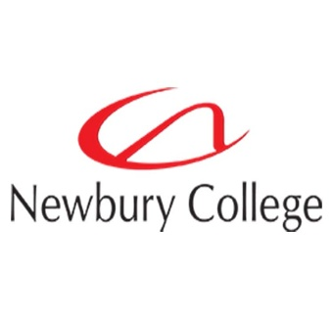

**NEWBURY COLLEGE**

We are working on our next set of events at Newbury College, but our Virtual Open Day is every day!

**Discover Newbury College!** [Open Events](https://newbury-college.ac.uk/openday)