Media Studies Summer Work

We are asking all students to complete some Independent Preparatory Work over the summer, before they join Year 12 in September. You will need to bring this work to lessons as the content will be assessed through introductory assessments which will be completed within the few first weeks of the new term.
Tasks
A Level Media Studies – Summer work
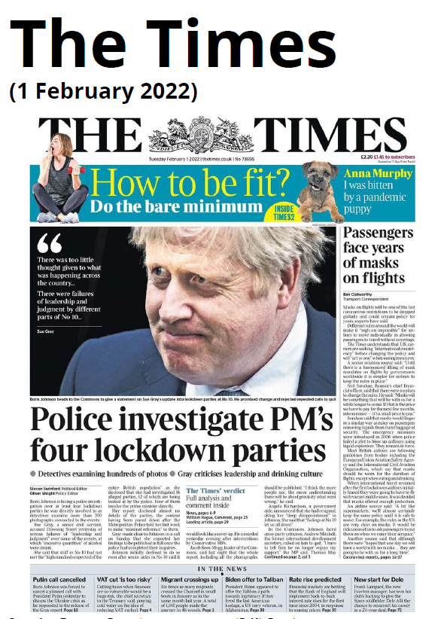
Welcome to A Level Media Studies, to help you prepare for September, I would like you to complete the following tasks.

- Newspapers - Study the newspaper front cover from The Times (01/02/22)
Then answer the following questions.
Better versions of the front covers can be accessed online: https://www.theguardian.com/politics/2019/mar/13/house-of-fools-what-the-papers-said-about-mays-brexit-defeat

- The Times is a ‘Quality’ newspaper or a ‘Small Format Broadsheet’ – what does this mean and what evidence can you find in the front cover to justify this description?

- The Times is described as having a centre-right-wing political opinion – what does this mean and what evidence can you find in the front cover to justify this description?

- The headline is “Driven to despair” – this could have various meanings to a reader, (straightforward or metaphorical/symbolic meanings). Consider this phrase and describe what you think the meanings are, linking your analysis to other visual and textual elements on the front page.

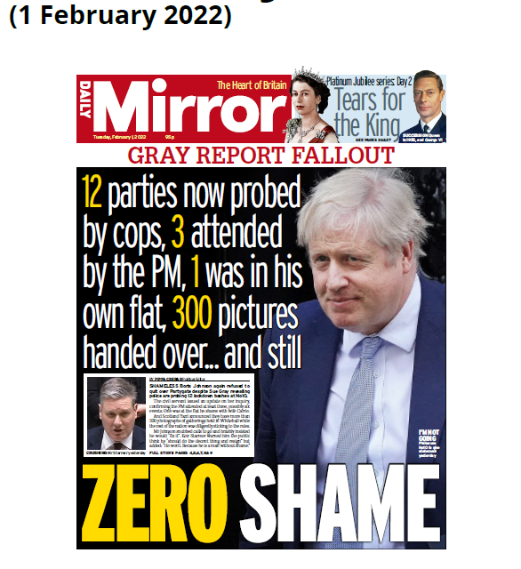
- Newspapers Study the newspaper front cover from Daily Mirror (01/02/22)

Then answer the following questions.
Better versions of the front covers can be accessed online:
https://www.theguardian.com/politics/2019/mar/13/house-of-fools-what-the-papers-said-about-mays-brexit-defeat

- The Daily Mirror is a ‘Tabloid’ newspaper– what does this mean and what evidence can you find in the front cover to justify this description?

- The Daily Mirror is described as having a leftwing political opinion – what does this mean and what evidence can you find in the front cover to justify this description?

- Almost half the cover is taken up with promotion of the Cheltenham Festival – Consider this event and then describe how it could be linked (metaphorically) with politics, therefore adding meaning to the story about Brexit underneath

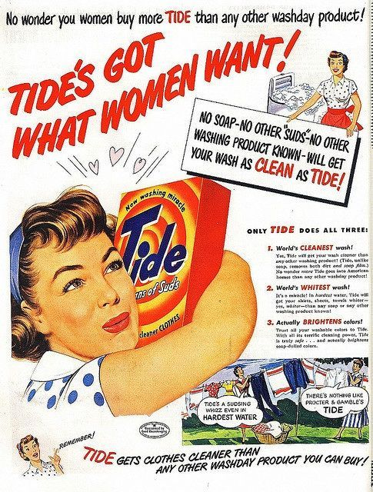
- Advertising – Study the Tide advert from the 1950’s
The UK regulators (the ASA) for advertising have recently changed the rules for how gender is represented.

Please read what they have ruled - https://www.asa.org.uk/advice-online/harm-and-offence-gender-stereotypes.html
Then apply what you had learned by answering the following questions.

- Describe the stereotype of femininity contained in the advert. Make reference to dress codes, hair & make up, body language and uses of language in the advert.

- Please explain why this advert would not be allowed today due to the new rules for advertising.

- Music Video - Study the video for Formation by Beyoncé - https://www.youtube.com/watch?v=WDZJPJV__bQ
Then answer the following questions.

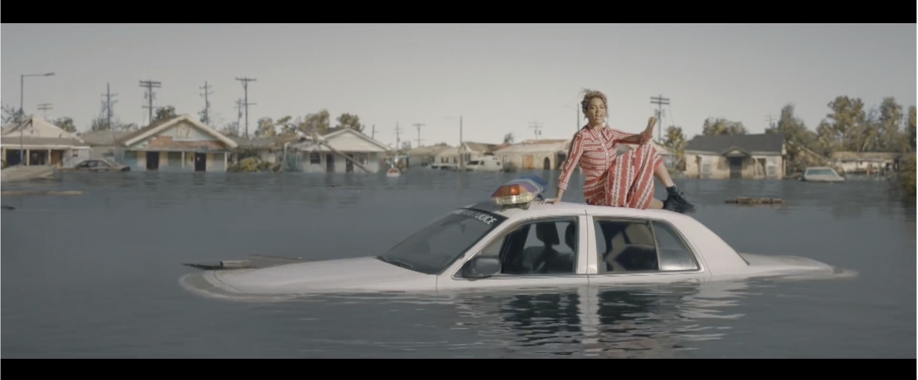
- Beyoncé has included information about the effects of flooding on New Orleans. Please investigate this and find out what caused this flooding (what was the event called?)

- Beyoncé uses this video to construct her ‘star persona’, (however, through doing this she also represents other Black American Women.)
What messages do you think she wanted her audience to see/hear? What are we supposed to think about Beyoncé and what does she think are important values? Link your answer to specific parts of the video.

- Film Marketing – Study the following teaser poster for Black Panther
Then answer the following questions
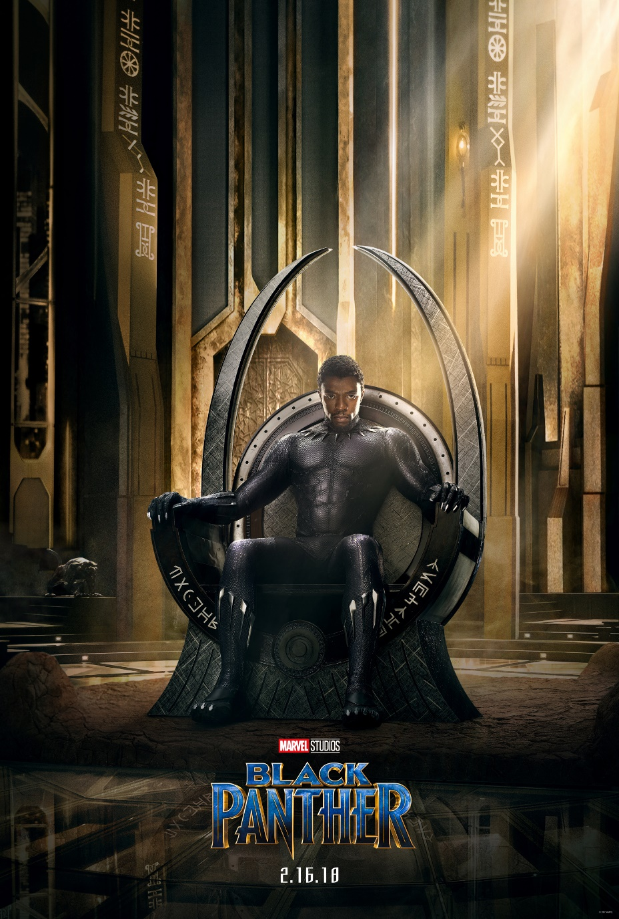
- What is the purpose of a Teaser Poster in a film marketing campaign?

- How does the audience know that this is a Teaser Poster? What specific elements of the poster send this message?

- How do you think that this poster is targeting the audience? Please comment on elements of narrative, genre and quality.

Please bring all completed work with you to the first lesson in September

Extra reading/Things to get:
Things to get for your first lesson in September:
- Big A4 ring binder folder
- File dividers (2 packs of 10)
- A4 Plastic Wallets
- Memory (USB) Stick – Minimum size of 64GB
- Highlighters (Pastel or normal)
- A4 Writing Pad

Note: If you are doing both Media Studies & Film Studies you do not need to buy two memory sticks. Please also note, that you will need double the file dividers (x40) and two big A4 ring binder folders – one for each subject.

